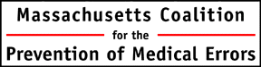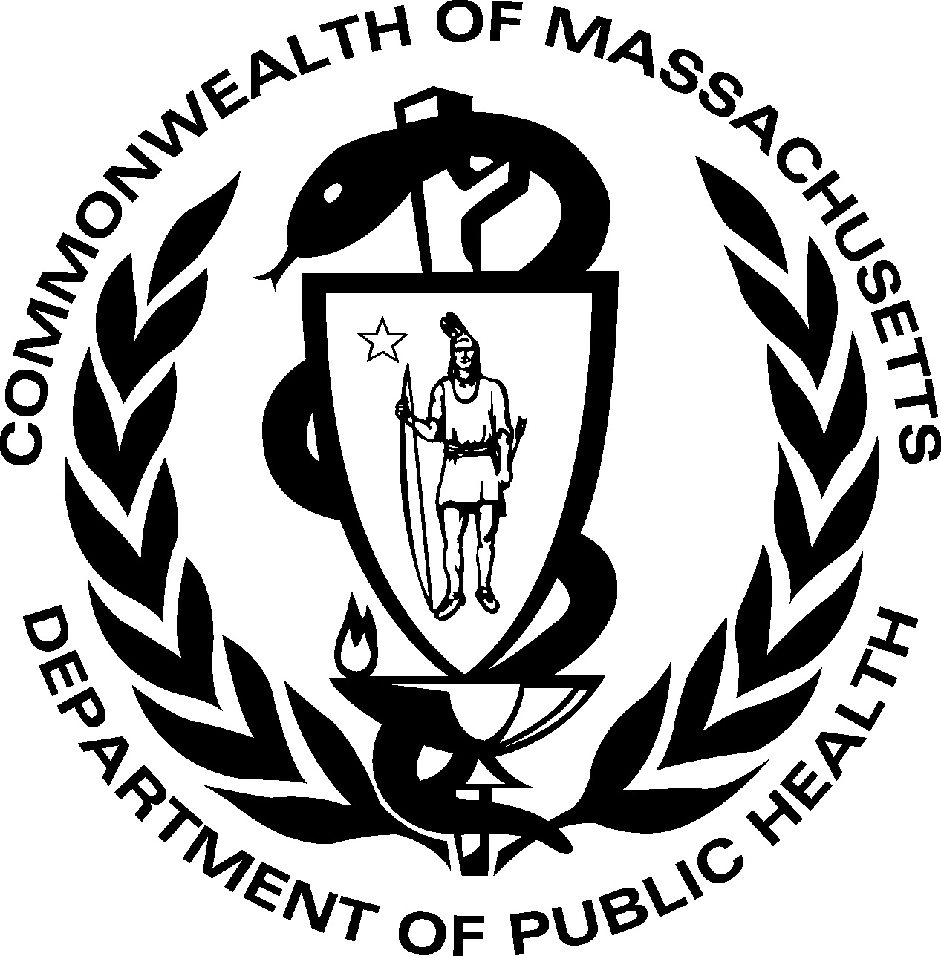

C. difficile Prevention Partnership Collaborative
Final Workshop
June 22, 2012 8:30 am - 2:30 pm
Doubletree Hotel, Westborough, MA

Join us to:
- learn strategies for infection prevention across the continuum, and hear how cross-facility teams worked to gain understanding of infection prevention within and between facilities
- get updates on hot topics in infection prevention
- ask experts your infection prevention questions (C. diff and beyond)
- hear specific infection prevention strategies that address the challenges of long term care

Who should attend?
Hospital and long term care teams in the C. difficile Prevention Partnership Collaborative

- Hospitals consider including: infection preventionist, environmental services staff, case manager or social worker (whoever does your discharge planning), microbiologist, infectious disease specialist, and pharmacist.
- Long term Care Facilities consider including: infection prevention nurse, environmental services director or staff, administrator, director of nurses, med director or nurse practitioner, member of your front line staff (nurse and CNA), consultant pharmacist, social worker (or whoever does your patient intake).

Guest faculty includes:
- Phenelle Segal RN, CIC, President, Infection Control Consulting Services: expert in acute and long term care infection prevention
- Sharon Benjamin, Ph.D., Principal, Alchemy: expert in organizational improvement and staff engagement strategies.
- Collaborative teams: experts in how to improve infection prevention on the front lines of care

Fees and Registration:
Each facility may register 3 participants at no cost. If you would like to send additional team members, please contact Fiona Roberts at 781-262-6080 or froberts@macoalition.org to place them on a waiting list.

This work is being done in collaboration with the Massachusetts Department of Public Health with funding from the Centers for Disease Control. As such, we are able to waive registration fees for this workshop in appreciation for the hard work done by Collaborative members.

CME and CE Information:
This program is good for 4.25 CME credits and 5.1 Nursing CEs. Please see the language below for further details.

Register now: http://www.regonline.com/builder/site/?eventid=1105188

Registration: 8:30 AM
Program Begins: 9:00 AM

Physicians: Masspro designates this live activity for a maximum of 4.25 AMA PRA Category 1 Credits™. Physicians should claim only the credit commensurate with the extent of their participation in the activity.

This activity meets the criteria of the Massachusetts Board of Registration in Medicine for risk management study.

This live activity has been planned and implemented in accordance with the Essential Areas and Policies of the Massachusetts Medical Society for Continuing Medical Education through the Joint Sponsorship of Masspro and the Massachusetts Coalition for the Prevention of Medical Errors and the Massachusetts Department of Public Health.

Masspro is accredited by the Massachusetts Medical Society to provide continuing medical education for physicians.

Pharmacists: This live activity meets the program and administration requirements of the Massachusetts Board of Registration in Pharmacy at regulation 247CMR 4.00: Sections 4.03 and 4.05 for 4.25 AMA PRA Category 1 Credits™.

Nursing Home Administrators: This live activity meets the program and administration requirements of the Massachusetts Board of Registration of Nursing Home Administrators at regulation 245CMR 2.12(4) for 4.25 contact hours (Deemed Status NH-09015-016).

Nurses: This program meets the requirements for 5.1 contact hours for Continuing Education in Nursing in Massachusetts pursuant to 244 CMR 5.00, the Board of Registration in Nursing Rules and Regulations

